Ads Mob Plug

1. Introduction

Ads Mob is a Google advertised type for displaying ads in application.

There are 4 types of advertisement provided by Google as

1. **Banner**: Banner ads are rectangular image or text ads that occupy a spot within an app's layout. They stay on screen while users are interacting with the app, and can refresh automatically after a certain period of time
2. **Interstitial**: Interstitials are full-screen ads that cover the interface of an app until closed by the user. They're best used at natural pauses in the flow of an app's execution, such as in between levels of a game or just after completing a task.
3. **Native**: Native is a component-based ad format that gives you the freedom to customize the way assets like headlines and calls to action are presented in their apps. By choosing fonts, colors, and other details for yourself, you can create natural, unobtrusive ad presentations that can add to a rich user experience.
4. **Rewarded video**: Rewarded video ads are full screen video ads that users have the option of watching in full in exchange for in-app rewards.

2. Pre-requisites:

Language: Swift 4.0 and above

IDE: Xcode 9 and above

3. Features list

1. Banner ads mob
2. Interstitials ads mob
3. Native ads mob
4. Rewarded ads mob
5. No internet plug

4. Screenshots

**Description**: Default home screen view with different ads type with respected info button.

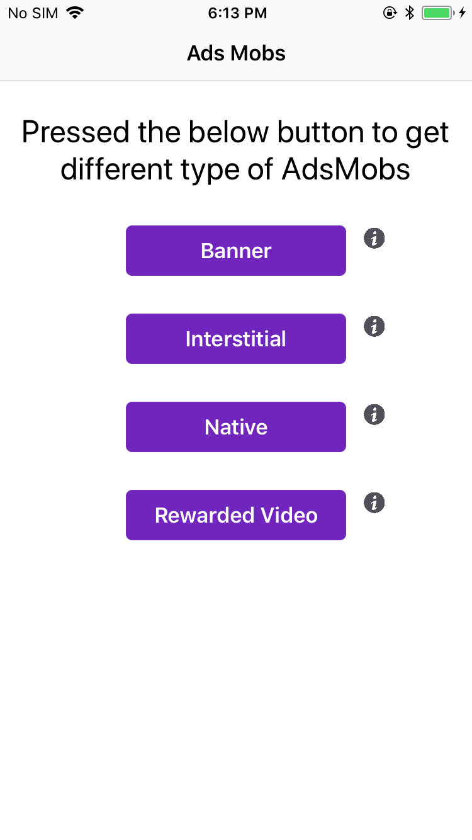

**Description**: Showing banner ads view.

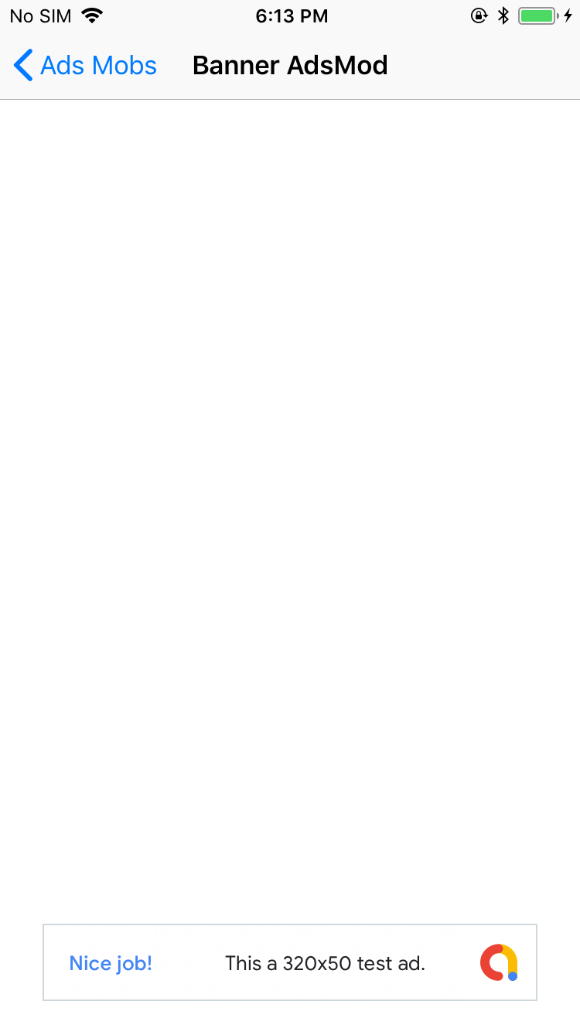

**Description**: Showing Interstitial ads view before loads view.

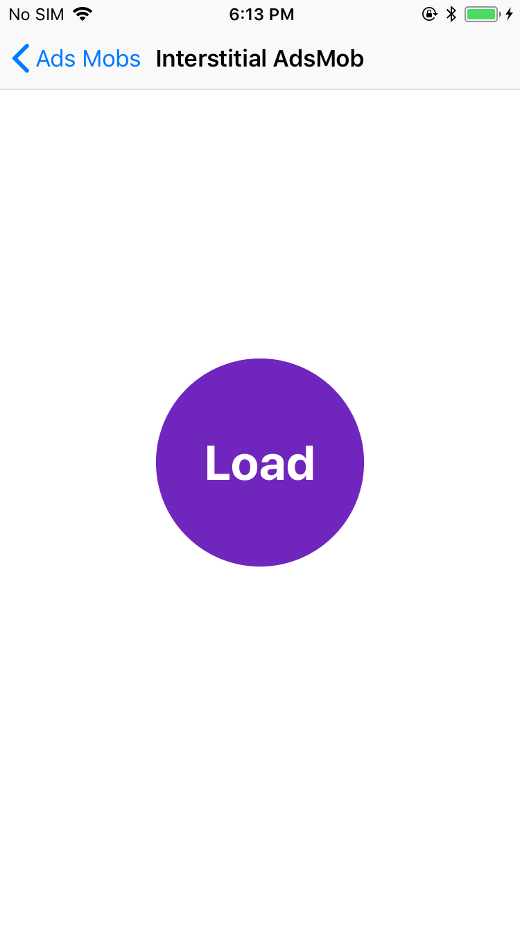

**Description**: Showing interstitial ads.

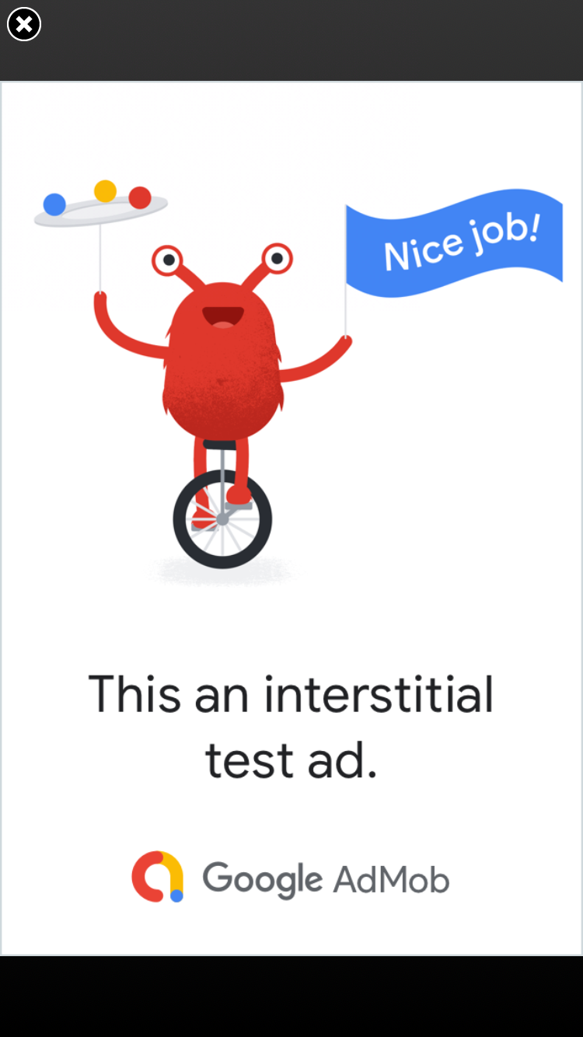

**Description**: Showing native ads view default page.

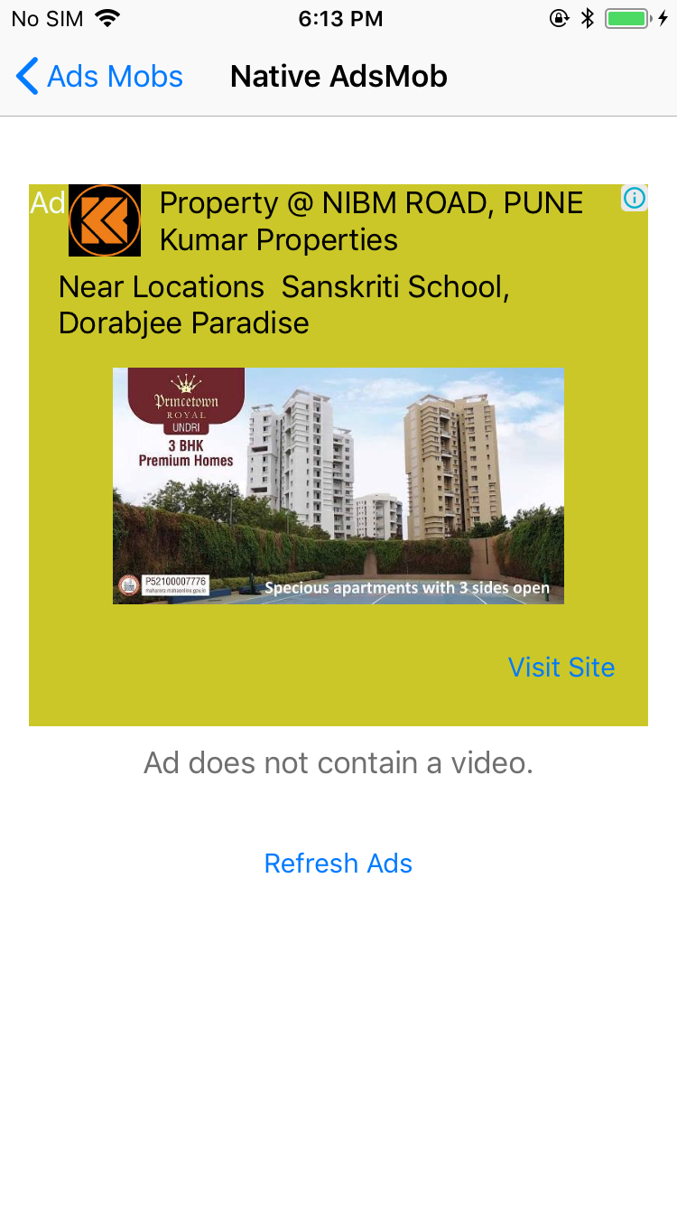

**Description**: After loading native ads.

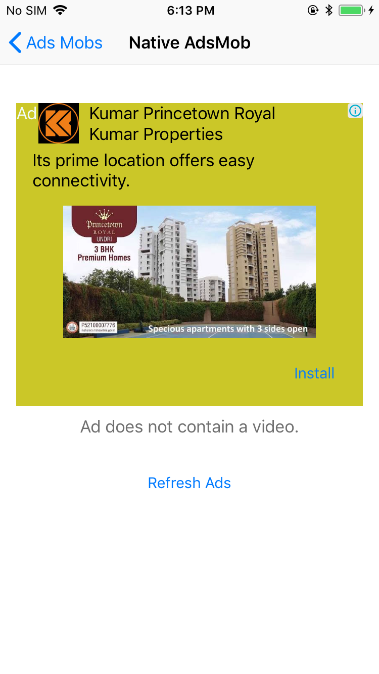

**Description**: Showing rewarded video default view before loading ads view with point description.



**Description**: Showing view after loading video object.



**Description**: Showing rewarded video.

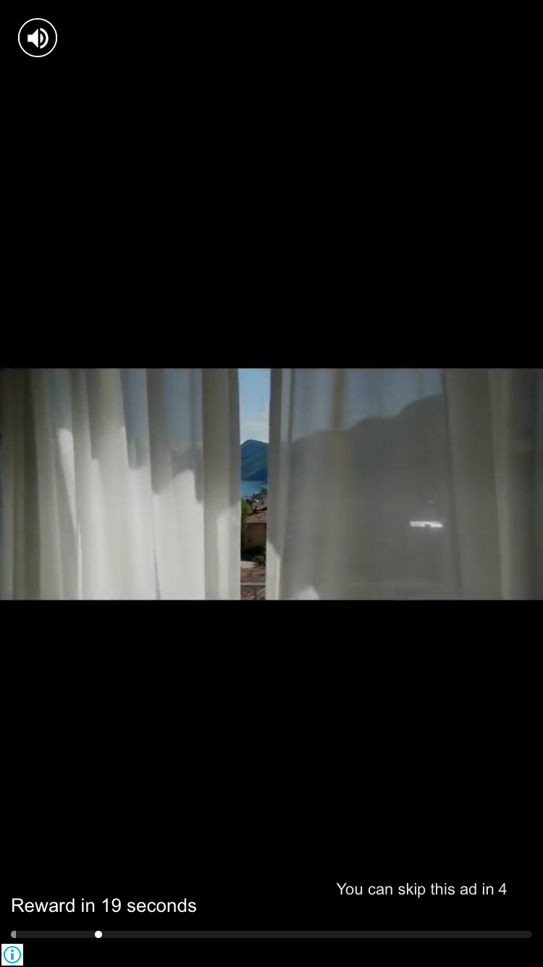

**Description**: After getting reward , showing rewards.



**Description**: Showing respected ads info with image.

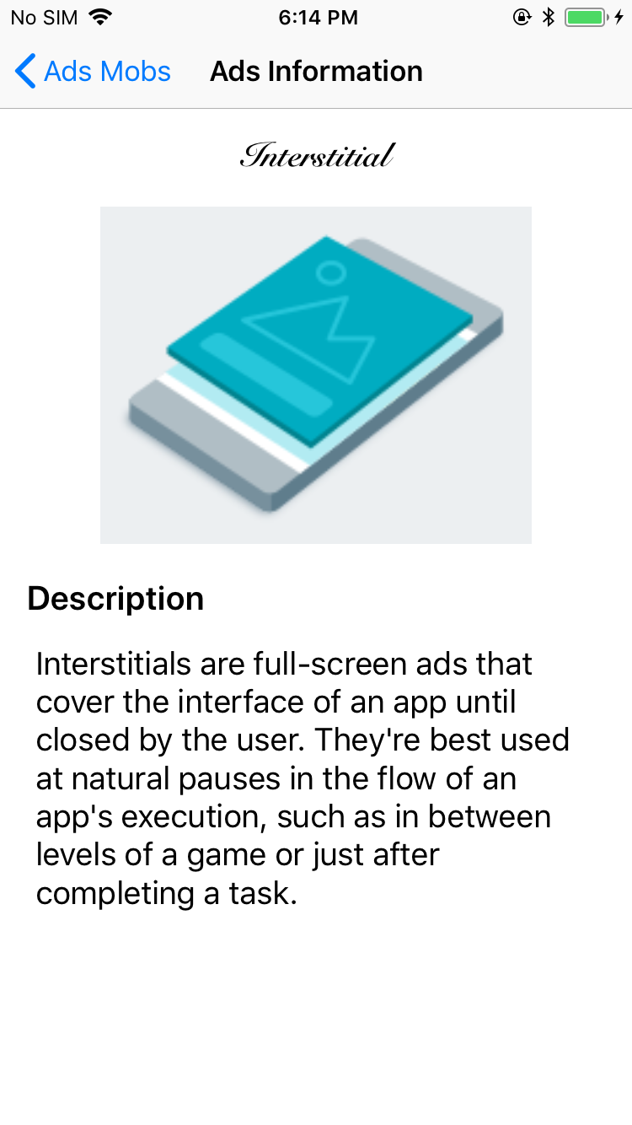

5. Steps to integrate / use / installation

1. Create Xcode project.
2. Create account on <https://apps.admob.com/> and create app and configure
3. Link admob to firebase and create or used existing project.
4. Generate AdMob Id for different type of ads.
5. Use CocoaPods and install Pod ‘Firebase/Core’ & ‘Firebase/AdMob’
6. Configure Firebase
7. Read docs here <https://firebase.google.com/docs/admob/ios/quick-start?authuser=0> and
8. Import SwiftGifOrigin in viewcontoller.
9. Set .gif file to UIImageView.

6. Credentials

**Username**: [obplugable@gmail.com](mailto:obplugable@gmail.com)

**Password**: Reset1234

7. Contact us / Support

[Support@plug-able.com](mailto:Support@plug-able.com)

Reference link: https://developer.apple.com/documentation/uikit/uiactivityindicatorview?changes=_5

https://github.com/swiftgif/SwiftGif